

FPT-aptech computer education

Online Music Streaming App Documentation

Music for life - Group 5
Group Member | Lý Quốc Trọng - D00667  Hoàng Tiến Luân - D00236  La Văn Phương – D00631  Vũ Thị Thu Hương - D00655  Nguyễn Tuấn Anh- D00633
Instructor | Nguyễn Tuân

- Hanoi, 1/2020 -

1.Index:

1.Index: 2

2. Problem Definition 2
2.1. Problem Abstraction 2
2.2. Development Environment 5

3. Requirements and Business Flow 6
3.1. User Requirement Specification 6
3.2. Activity Diagram 6
3.3. Use Case Diagram 42
3.4. Use Case Specification 44

4. Design 68
4.1. System Architecture 68
4.2. Class Diagram 68
4.3. Class Diagram Explanation 78
4.4. Sequence Diagram : 79
4.5. Entity Relationship Diagram 115
4.6. Database Design 116
4.7. Algorithms (optional) 123

5. System Prototype 124

6. Screenshots 128

Problem Definition

Problem Abstraction

Build an android music streaming app with features:
- Listen music online
- Upload and download favorite songs
- List of most listen and favorite songs recommend for user
- Album daily, weekly and trending songs
- Search song
- Pages and posts for update newest song and event ( developing )
- Comment under post and song for user ( developing )

Development Environment
Hardware
- Intel core i5 6200U 2.8Gz
- Hard disk requirement: minimum 60 GB.
- 4 Gigabyte of Ram or higher.
Software
- Chrome, Firefox
- Android Studio, Intellij IDEA
- Microsoft Word 2010.
- Windows 7 or higher

Activity Diagram
- Activity diagram “ Register”

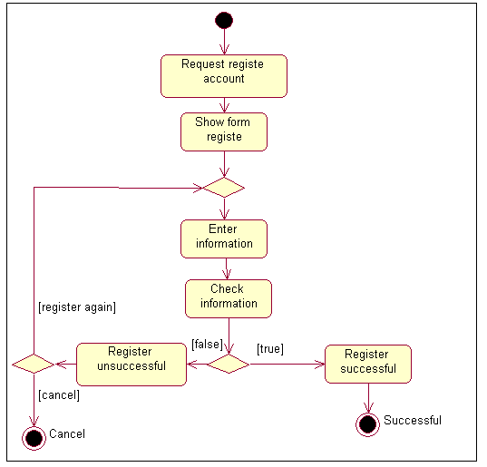

- Activity diagram “Login”
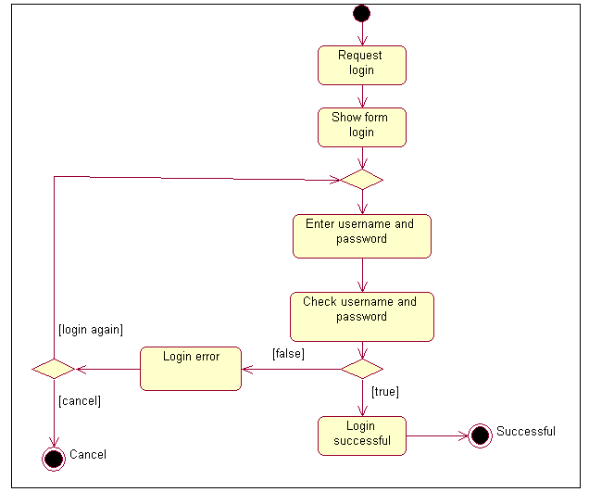

- Activity diagram “ Update profile ”
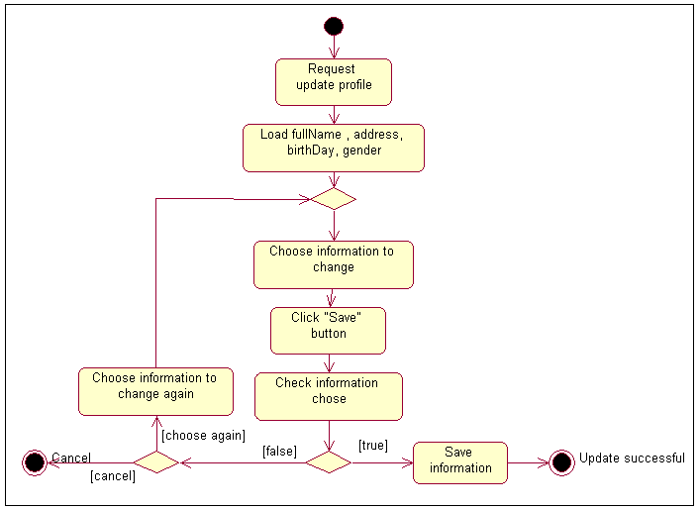

- Activity diagram “ Change password ”
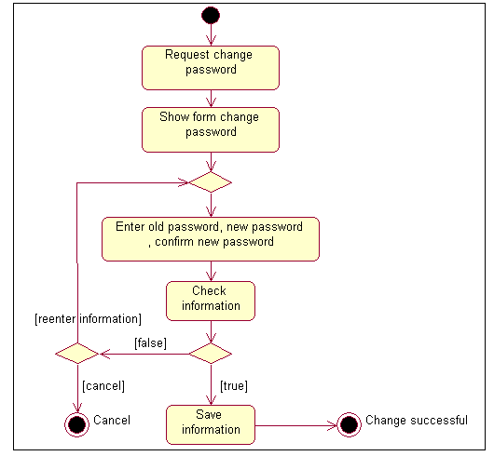

- Activity diagram “ Search song“
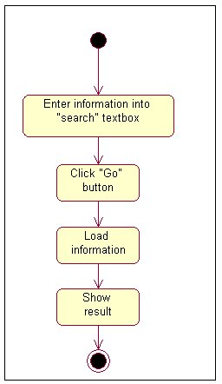

- Activity diagram “ Manage“ ( Song, Album, Playlist, Post, AdsSong, AdsPlaylist )

Click on entity in manage page

Show form of entity

Edit item button
Add new item button
Delete item button

Show information changed

- Activity diagram “ Add song“ ( Same as Album, Playlist, Post, AdsSong, AdsPlaylist )

Click “Add new song” button

Show form add song

[ Re enter information ]

Enter information

Cancel
Check information

Save information
Show error
True
False

- Activity diagram “Edit song” ( Same as Album, Playlist, Post, AdsSong, AdsPlaylist )

Request to edit

Show form edit
Re enter information

Enter information
to change

Click “Cancel” button

Click “Save” button
False
Edit error
True

Edit sucessful
Save information

- Activity diagram “Delete song” ( Same as Album, Playlist, Post, AdsSong, AdsPlaylist)

Choose song to delete

Click “Delete” button

Save information changed

Show successful message

Use Case Specification

Use Case Name | Register
Actors | User
Brief Description | - Use case allows the User register to system
Preconditions | - The person has not already been registered with System
Basic Flow of Events | 1. The use case begins when User click on “register “ button in website.  2.The system show register form contains  Fields:  - User name.  - Password.  - Email.  3. User enter information into form.  4.The system checks the validity of the information.  5. Save information of User to database  6.System display successful register message.
Alternative Flows | A1.Exist user name:  If in step 4 of the basic flow User enter a username existed in the database then:  - System display error message.  - The use case resumes at step 3 of Basic Flow enter other username.  A2.Email not valid:  If in step 4 of the basic flow User enter a username existed in the database then:  - System display error message.  - The use case resumes at step 3 of Basic Flow re-enter email address.
Exit Options | - User click on “Cancel” button
Special Requirements
Post Condition | - User have a new account in system.

Use Case Name | Login
Actors | User, admin.
Brief Description | -Actors use this use case to login to system
Preconditions
Basic Flow of Events | 1. Actors click on “Login “ button in website.  2.The system show” login” form contains  Fields :  - User name.  - Password.  3. Actors enter username and password into form.  4.The system checks the validity of username and password .  5.System logs the Actors into the system.
Alternative Flows | If in the step 4 Basic Flow,User enter invaild user name and/or password then:  1.System display error message.  2.The use case resumes at step 3 of Basic Flow.
Exit Options | - Actors click on “Cancel” button
Special Requirements
Post Condition | - Actors login to system

Use Case Name | Update profile
Actors | User,admin
Brief Description | -User use this use case to update personal information to system
Preconditions | The User must be logged into system before this use case begins.
Basic Flow of Events | 1. The use case begins when User click on “Update information” menu on the website.  2.The system load personal information of User.  3.The system display information into ” Update” form contains Fields:  - FullName.  - Address.  - BirthDay.  - Gender.  4. User change information in form.  5.User click on “Save” button.  6.The system checks the validity of the information.  7.System save information to data base.  8. System display successful message.
Alternative Flows | If in the step 6 Basic Flow,User enter invaild infromation:  1.System display error message.  2.The use case resumes at step 4 of Basic Flow.
Exit Options | - User click on “Cancel” button
Special Requirements
Post Condition | - Personal information of User is updated to data base.

Use Case Name | Change password
Actors | User,deal-manager, admin
Brief Description | - Actors use this use case to chage password login to system
Preconditions | The Actors must be logged into system before this use case begins.
Basic Flow of Events | 1. The use case begins when Actors click on “Change password” menu on the website.  3.The system display ” change password” form contains Fields:  - Old password.  - New password.  - Confirm new password.  4. Actors enter information in form.  5. Actors click on “save” button.  6.The system checks the validity of the information.  7.System save information to data base.  8. System display successful message.
Alternative Flows | A1.Old password invalid.  If in the step 6 Basic Flow,User enter invalid old password :  1.System display error message.  2.The use case resumes at step 4 of Basic Flow re-enter old password.  A2. Confirm invalid.  If in the step 6 Basic Flow, Actors enter new password and confirm new password is not the same:  1.System display error message.  2.The use case resumes at step 4 of Basic Flow re-confirm new password.
Exit Options | - User click on “Cancel” button
Special Requirements
Post Condition | - password of User is changed to data base.

Use Case Name | View Product
Actors | User
Brief Description | - Use case allows the User view list products on the website.
Preconditions
Basic Flow of Events | 1. The use case begins when User click on “Product“ menu in the website.  2.System load products in database .  3.System display result to User.
Alternative Flows
Exit Options
Special Requirements
Post Condition | - list products are displayed.

Use Case Name | Search song. ( Album, Playlist )
Actors | User ,admin
Brief Description | - Use case allows the Actors search products
Preconditions
Basic Flow of Events | - This use case begin when actors enter text into search textbox then click on “Go” button.  - System perform the search as per the query parameters User enter.  - System display result search.
Alternative Flows
Exit Options
Special Requirements
Post Condition | - Result search is dispalyed.

Use Case Name | Manage song ( Album, Playlist, ...)
Actors | admin
Brief Description | - Use case allows the Actors manage Songs contain: add new ,edit , remove Songs.
Preconditions | -The actor must be logged into system before this use case begins.
Basic Flow of Events | - This use case begin when actors click on Songs entity  - System display list all Song in database and buttons: “add new song” ,”edit song”, ” delete song”.  -If actor click “add new Song” use case “add song” is executed.  -If actor click “edit Song” use case “edit song” is executed.  -If actor click “remove Song” use case “remove song” is executed.
Alternative Flows
Exit Options
Special Requirements
Post Condition | - Song is added,edited or removed

Use Case Name | add Song ( Album, Playlist, … )
Actors | Admin
Brief Description | - Use case allows the admin add new Song.
Preconditions | -The actor must be logged into system before this use case begins.
Basic Flow of Events | 1. The use case begins when actor click on “add new Song” button.  2.The system show add new Song form contains  Fields:  - SongName.  - Genre  - Country.  - Avatar  - SongAddress  3. actor enter information into form.  4.The system checks the validity of the information.  5. Save information of Song to database  6.System display successful message.
Alternative Flows | A1.Email not valid:  If in step 4 of the basic flow User enter a usename existed in the database then:  1. System display error message.  2. The use case resumes at step 3 of Basic Flow re-enter email address.  A2.( SongName, Genre, Country,Avatar, SongAddress) is null:  If in step 4 of the basic flow actor not enter ( SongName, Genre, Country,Avatar, SongAddress) then:  1.System display error message.  2.The use case resumes at step 3 of Basic Flow enter requiment information.
Exit Options | - actor click on “Cancel” button
Special Requirements
Post Condition | - A new Song is create.

Use Case Name | Edit Song ( Album, Playlist, ...)
Actors | Admin
Brief Description | - Use case allows the admin edit Song.
Preconditions | -The actor must be logged into system before this use case begins.
Basic Flow of Events | 1. The use case begins when actor chose Song want to edit then click on “Edit Song” button.  2.The system load information of Song into form contains :  - SongName.  - Genre  - Country.  - Avatar  - SongAddress  3. actor change information in form.  4.The system checks the validity of the information.  5. Save information of Song to database  6.System display successful message.
Alternative Flows | A1.Email not valid:  If in step 4 of the basic flow User enter a usename existed in the database then:  1. System display error message.  2. The use case resumes at step 3 of Basic Flow re-enter email address.  A2.( SongName, Genre, Country,Avatar, SongAddress) is null:  If in step 4 of the basic flow actor not enter ( SongName, Genre, Country,Avatar, SongAddress ) then:  1.System display error message.  2.The use case resumes at step 3 of Basic Flow enter requiment information.
Exit Options | - actor click on “Cancel” button
Special Requirements
Post Condition | - Song is edited.

Use Case Name | Remove Song ( Album, Playlist, … )
Actors | admin
Brief Description | - Use case allows the admin remove Song.
Preconditions | - actor must to login into system
Basic Flow of Events | 1.The system display list Song .  2.Actor chose Song want to remove then click on “remove” button.  3. System remove Song from database.  4. System display success message.
Alternative Flows | .
Exit Options | - Actor click on “Cancel” button
Special Requirements
Post Condition | - A Song is removed.

- Sequence diagram “ Register“

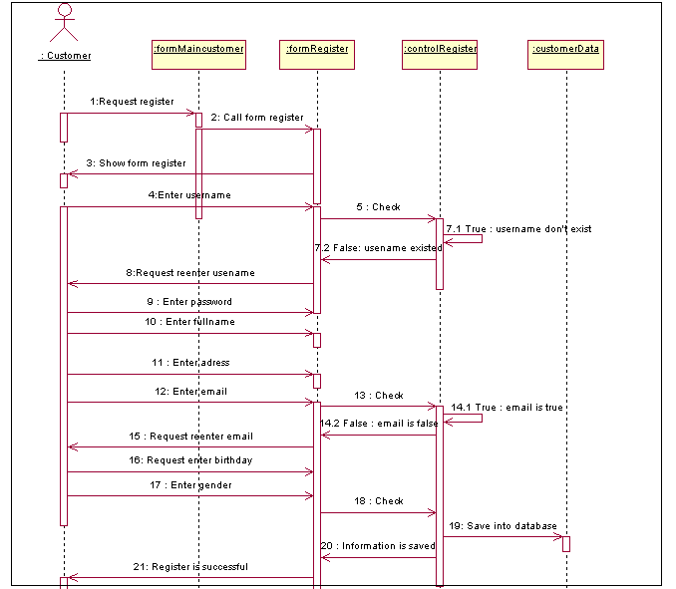

- Sequence diagram ” Update profile“

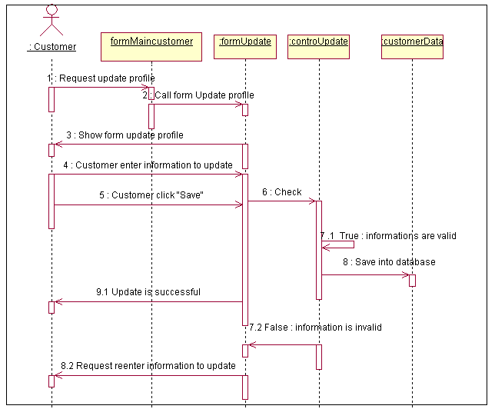

- Sequence diagram ”Login “

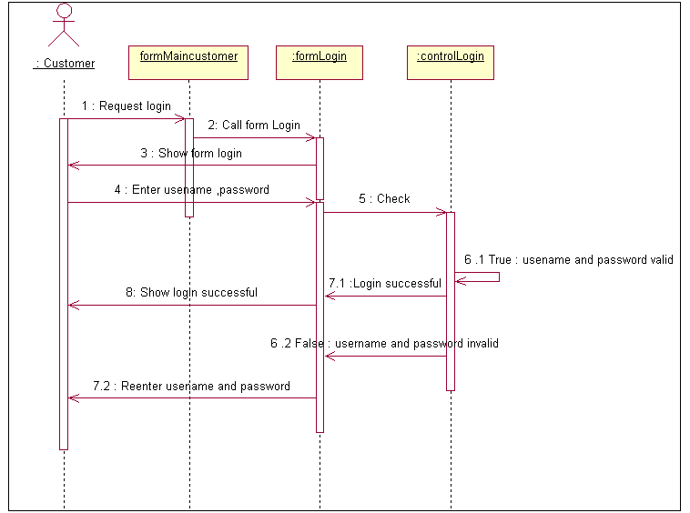

- Sequence diagram ” Change password“

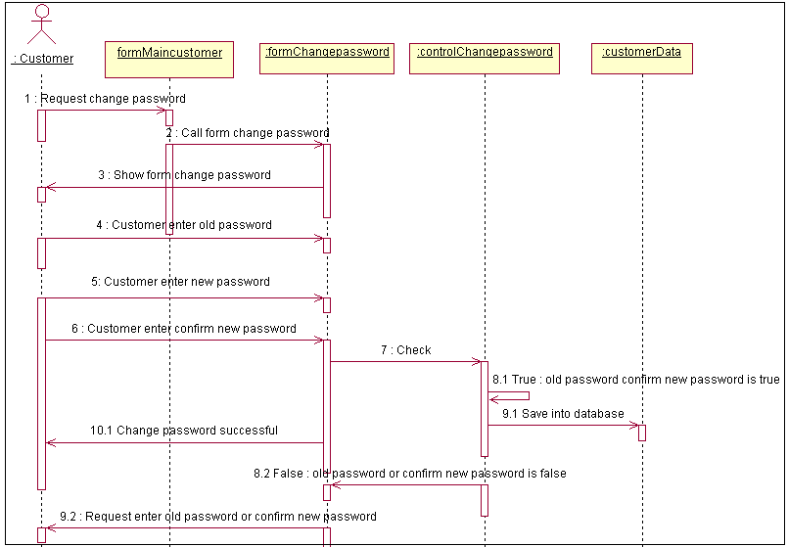

- Sequence diagram ”Search song“
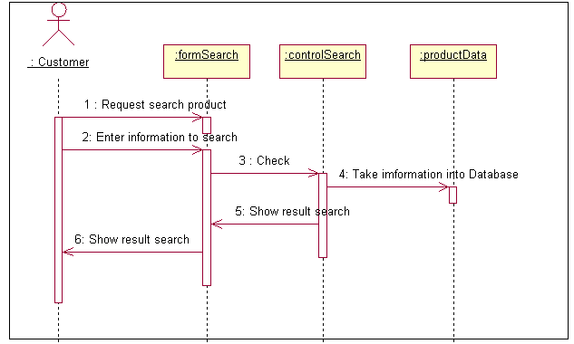

- Sequence diagram ”Manage song“ ( Album, Playlist, … )
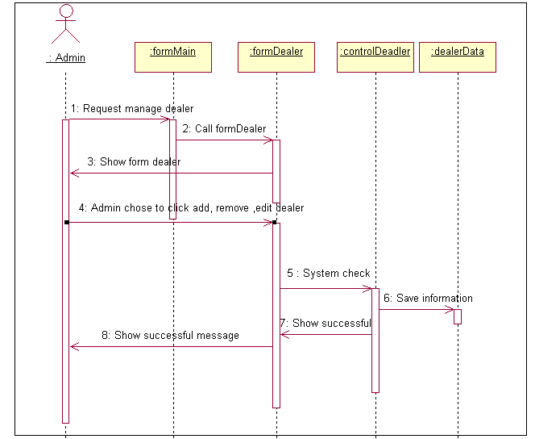

- Sequence diagram “ Edit song” ( Album, Playlist, … )

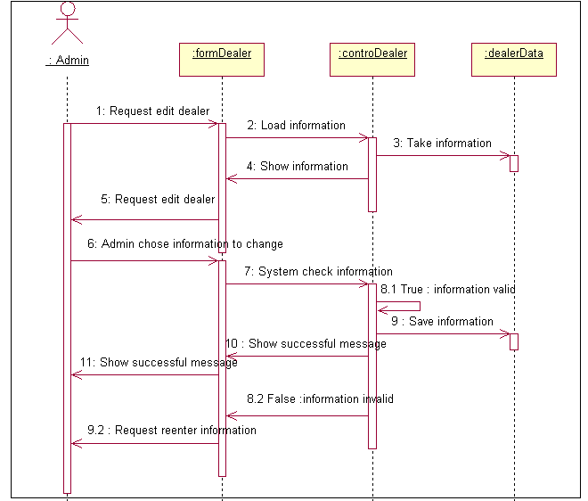

- Sequence diagram ”Delete song” ( Album, Playlist, ...)
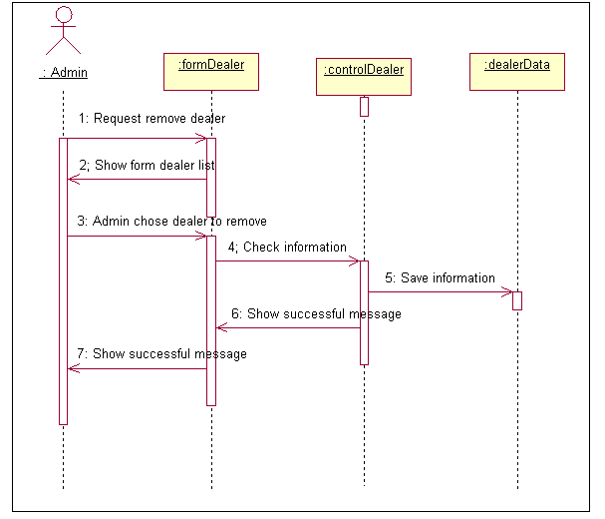

- Sequence diagram “Add song” ( Album, Playlist, ...)
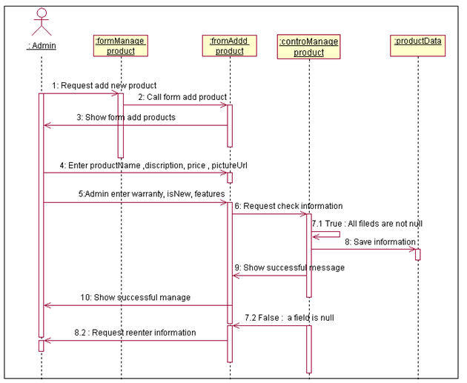

Entity Relationship Diagram

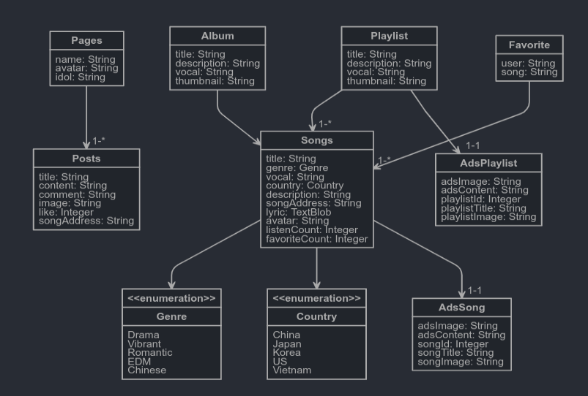

Database Design

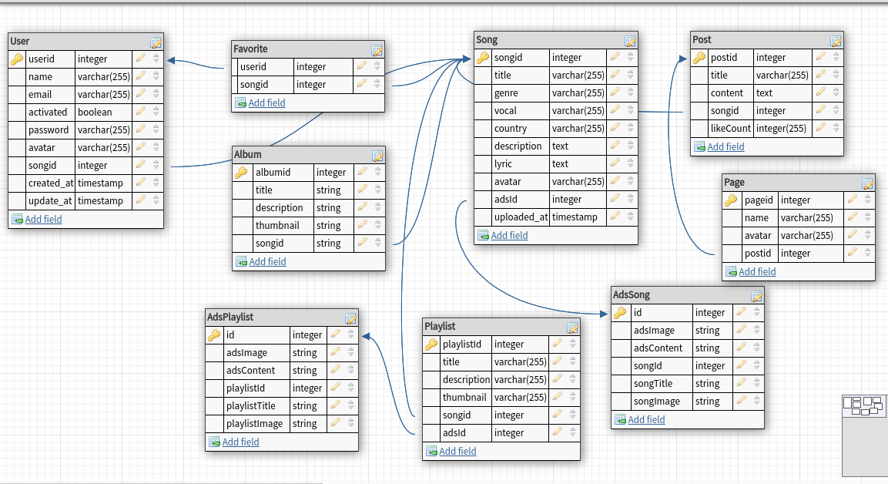

Table : Song
Field Name | Data Type | Null | Key | Description
songid | INTEGER | No | PK | ID of song
title | nvarchar(255) | No |  | Title of song
genre | nvarchar(255) | No |  | Genre of song
vocal | varchar(255) | No | FK | Name of singer
country | nvarchar(255) | No |  | Country of song
description | varchar(255) |  |  | Description of song
lyric | text(2000) |  |  | Lyric of song
avatar | nvarchar(500) |  |  | Avatar cover of song

Table : Users
Field Name | Data Type | Null | Key | Description
UserID | Int | No | PK | ID of User
userName | nvarchar(255) | No |  | UserName of User
password | nvarchar(255) | No |  | Password of User
fullName | nvarchar(255) | No |  | Full name of User
email | nvachar(255) | No |  | Email of User

Table : Post
Field Name | Data Type | Null | Key | Description
postid | Integer | No | PK | ID of post
title | nvarchar(255) | No |  | Title of post
content | nvarchar(255) | No |  | Post content
likeCount | Integer | No |  | Number of like in page

Table : Page
Field Name | Data Type | Null | Key | Description
pageid | Int | No | PK | ID of page
name | nvarchar(255) | No | PK | Name of page
avatar | nvarchar(255) | No |  | Avatar cover of page

Table : Favorite
Field Name | Data Type | Null | Key | Description
id | Int | No | PK | ID of favorite
userid | Int | No |  | ID of user
songid | int | No |  | ID of song

Table : Album
Field Name | Data Type | Null | Key | Description
albumid | Int | No | PK,FK | ID of the album
title | nvarchar(255) | No | PK,FK | Name of album
description | nvarchar(255) | No |  | Album description
thumbnail | nvarchar(255) |  |  | Avatar cover of album

Table : Playlist
Field Name | Data Type | Null | Key | Description
playlistid | Int | No | PK,FK | ID of the playlist
title | nvarchar(255) | No | PK,FK | Name of playlist
description | nvarchar(255) | No |  | Playlist description
thumbnail | nvarchar(255) |  |  | Avatar cover of playlist

Table : AdsSong
Field Name | Data Type | Null | Key | Description
id | Int | No | PK | ID of ads song
adsImage | nvarchar(255) | No | FK | Image ads
adsContent | nvarchar(255) | No |  | Content of ads
songId | Int |  |  | Id of song
songTitle | nvarchar(255) |  |  | Title of song
songImage | nvarchar(255) |  |  | Avatar of song

Table : AdsPlaylis
Field Name | Data Type | Null | Key | Description
id | Int | No | PK | ID of ads song
adsImage | nvarchar(255) | No | FK | Image ads
adsContent | nvarchar(255) | No |  | Content of ads
playlistId | Int |  |  | Id of playlist
playlistTitle | nvarchar(255) |  |  | Title of playlist
playlistImage | nvarchar(255) |  |  | Avatar of playlist

5.Screenshots

Admin home page
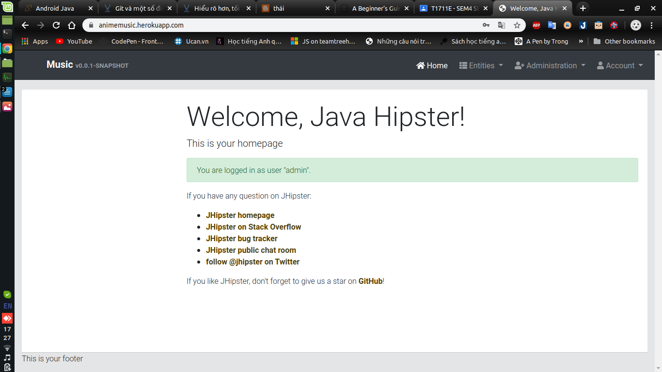
Admin login form
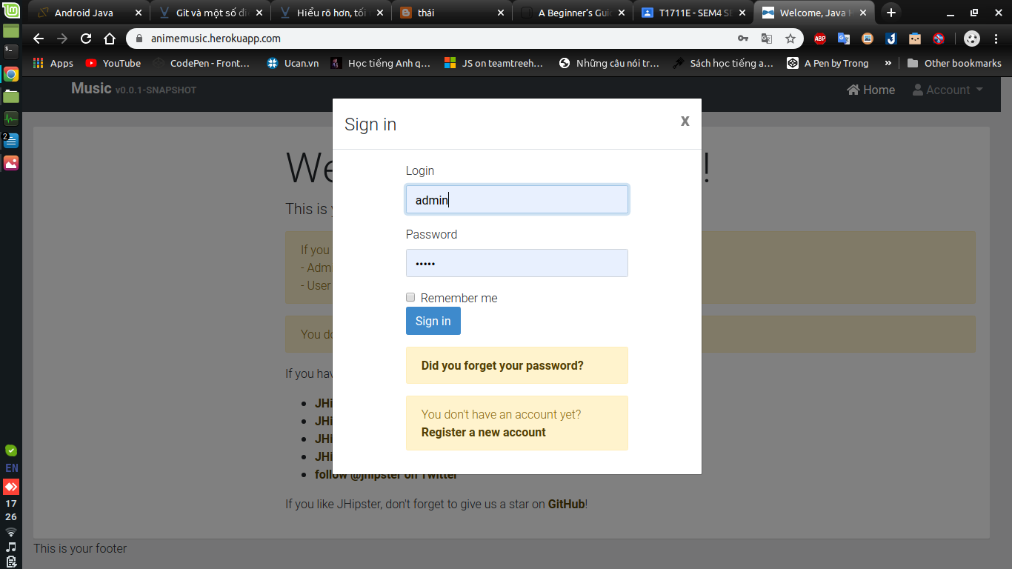
Manage User

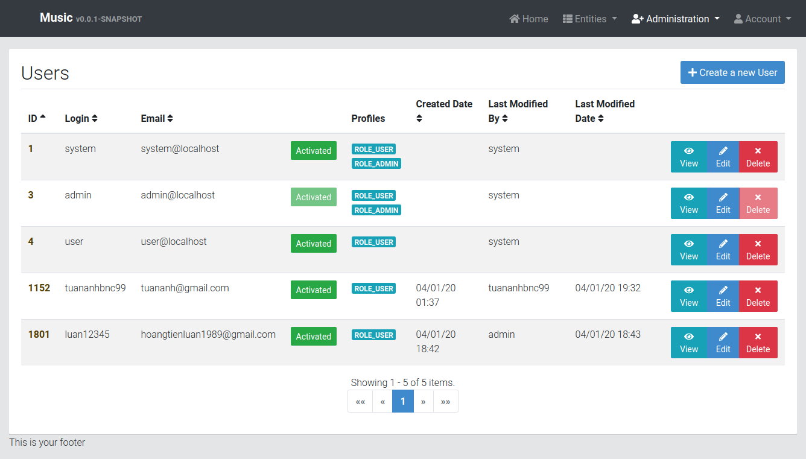
Manage Song
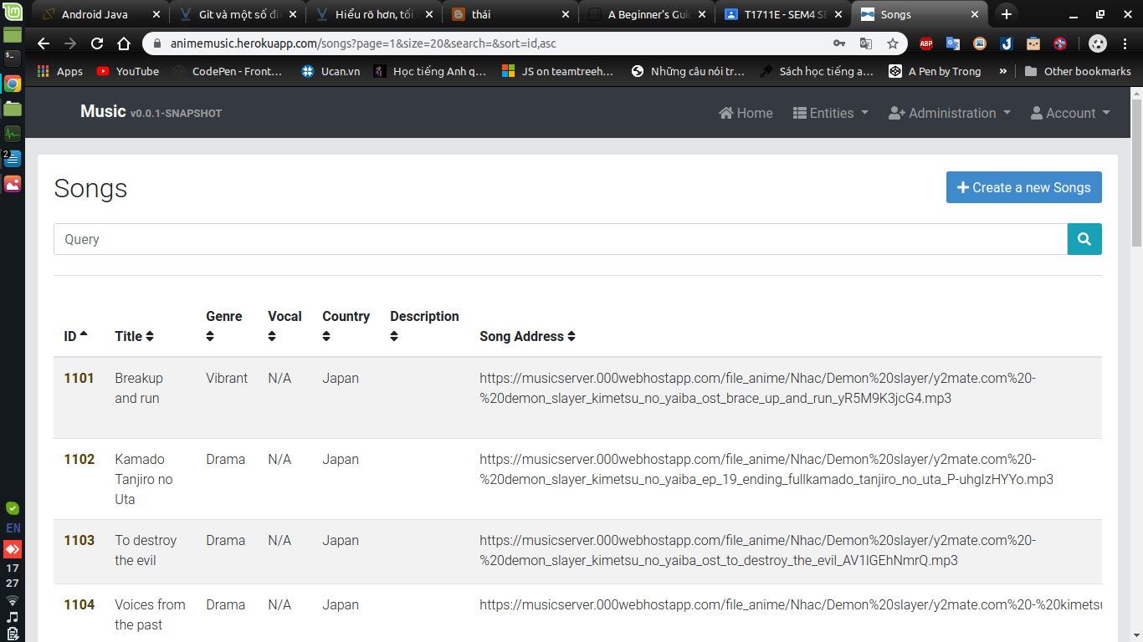

Manage Post

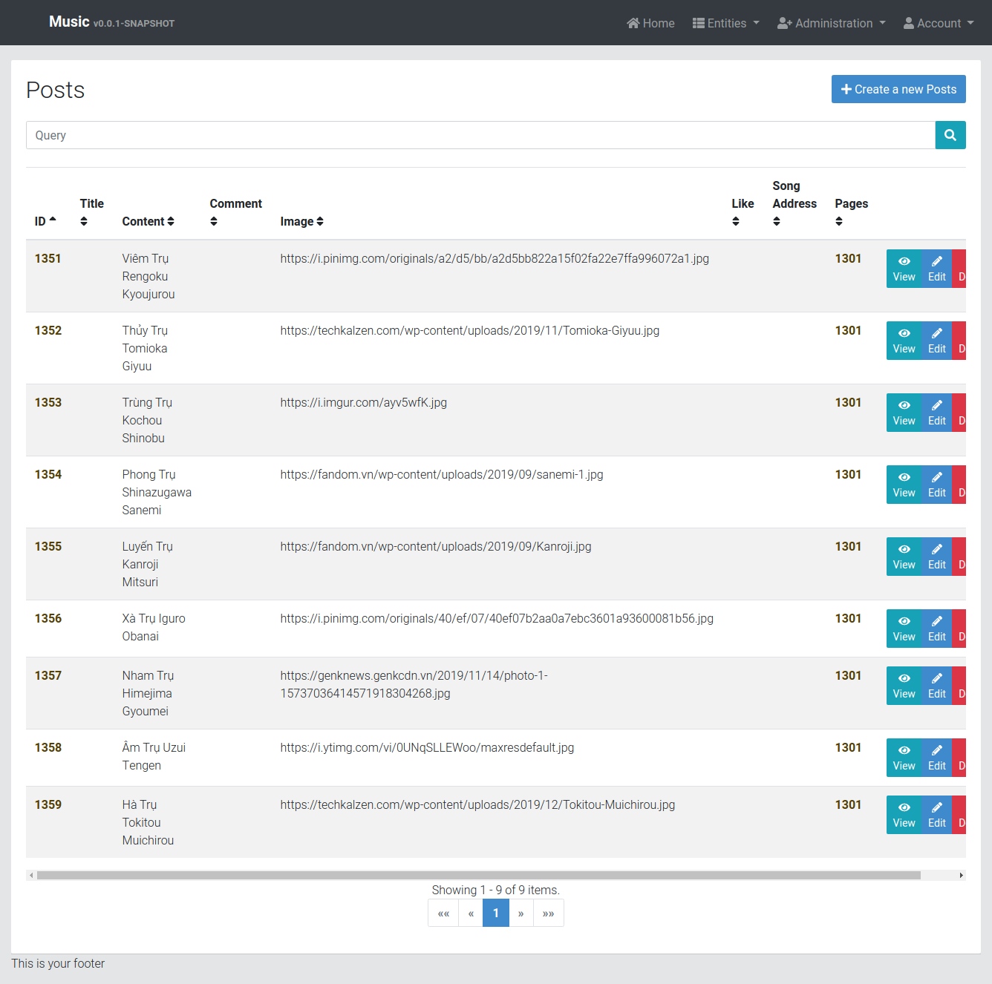

Manage Page

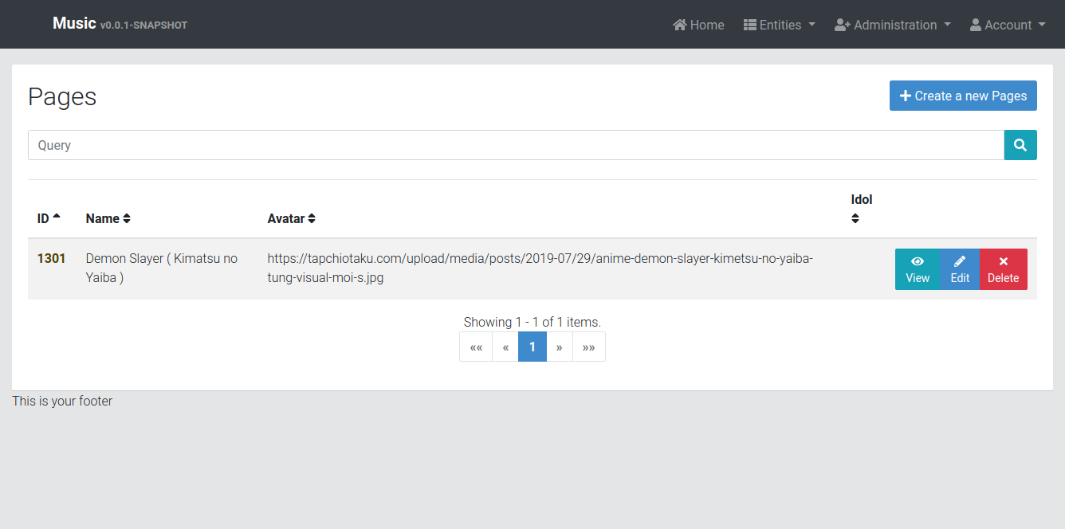

Manage Album

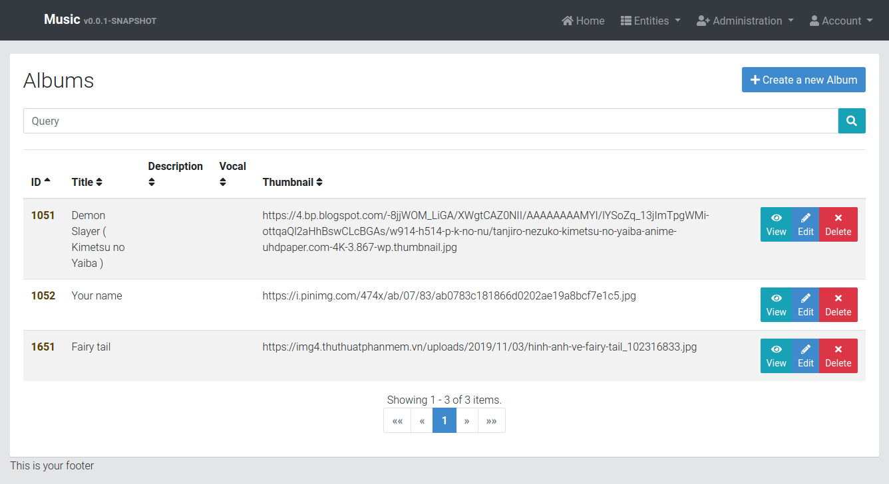

Add new Song

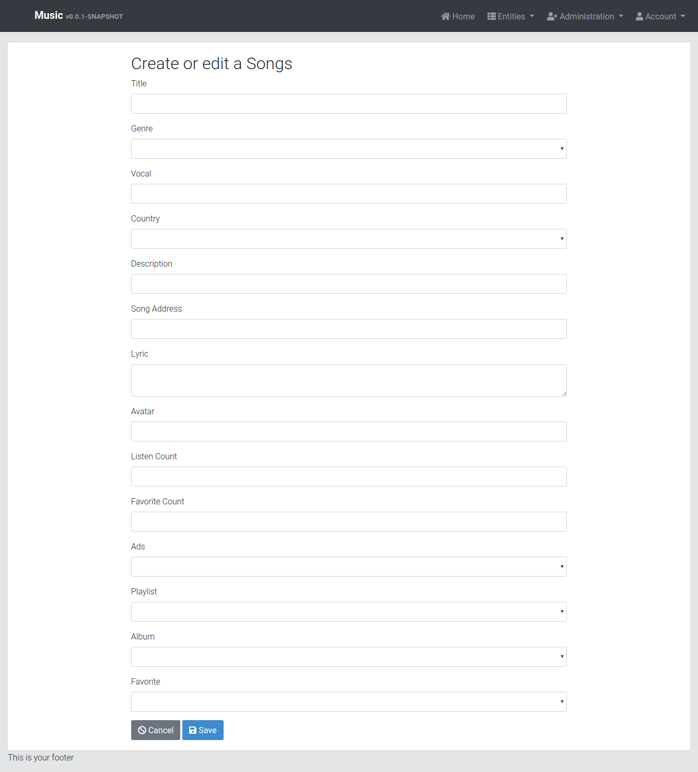

Create Page

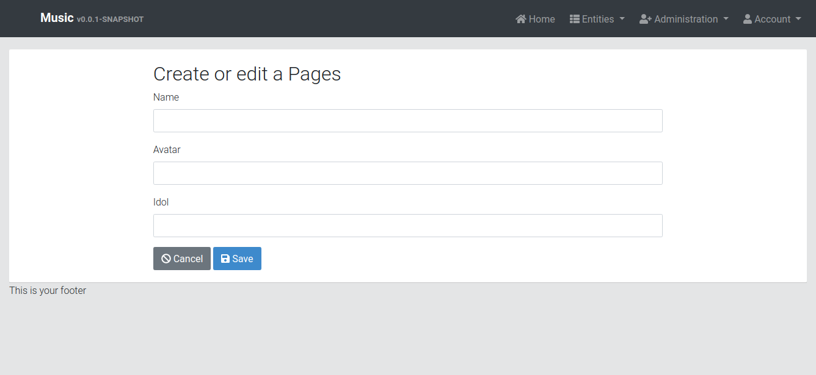

Create Post
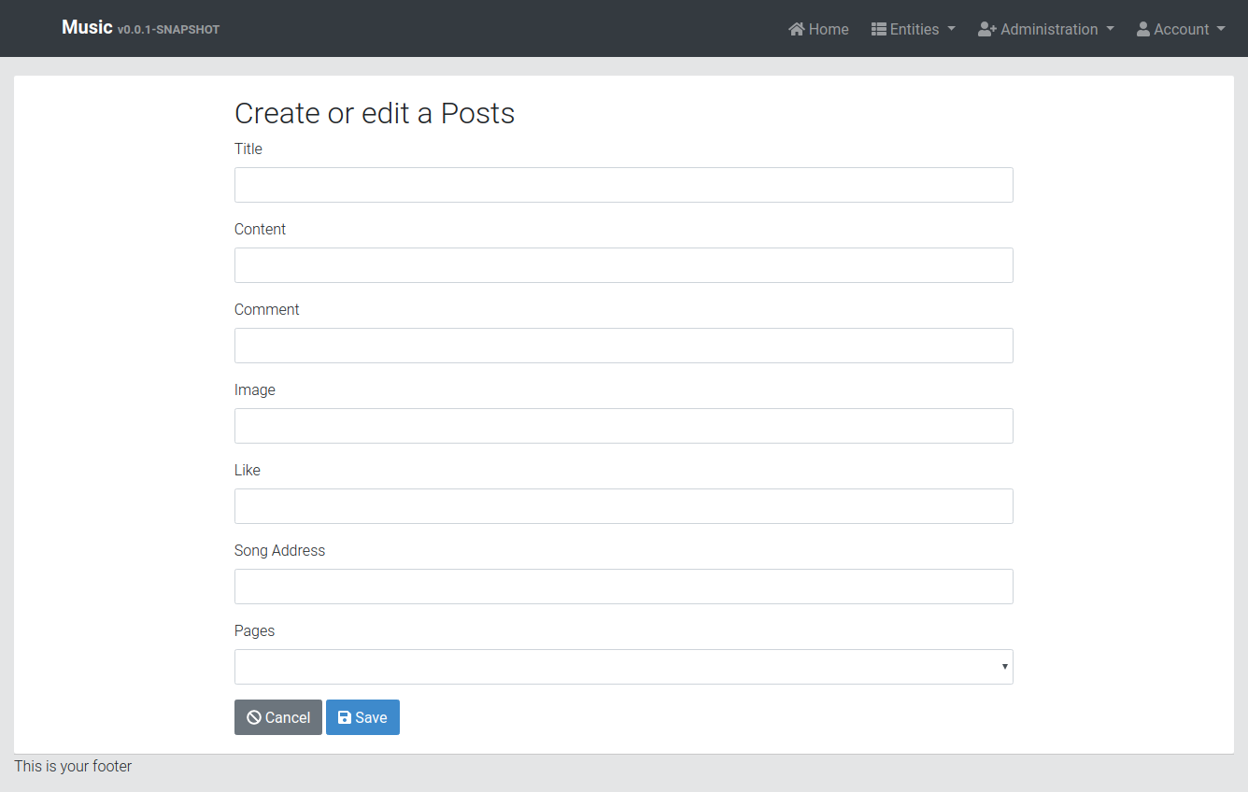

Edit Album
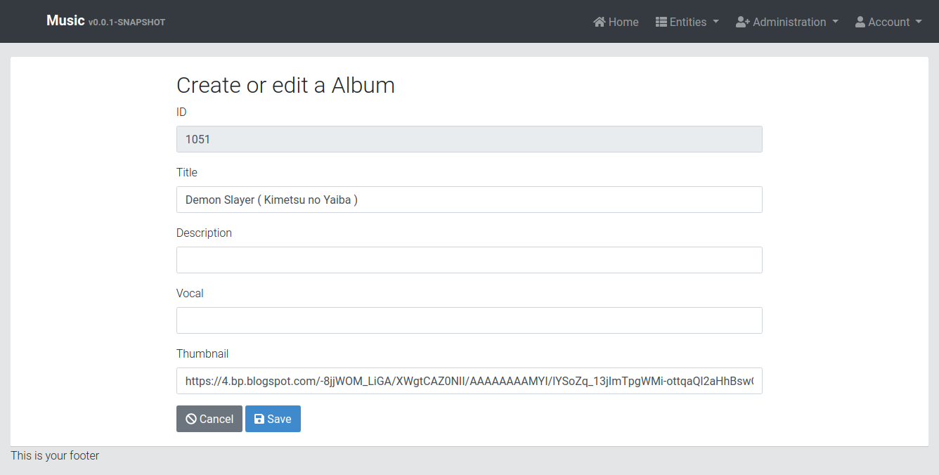

Edit Page

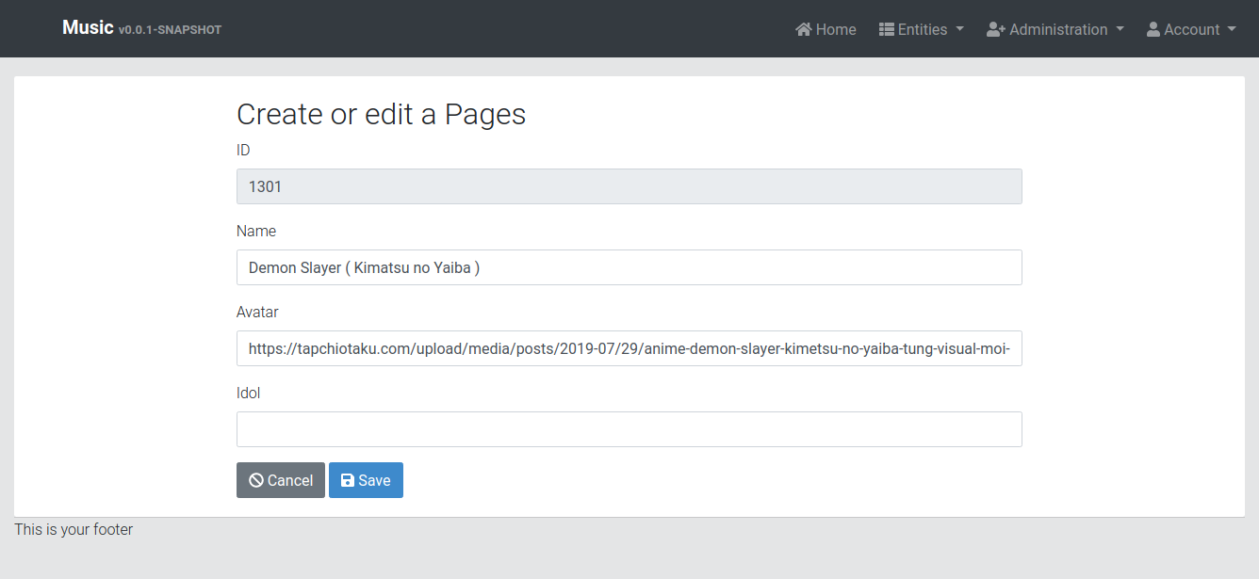

Edit Post
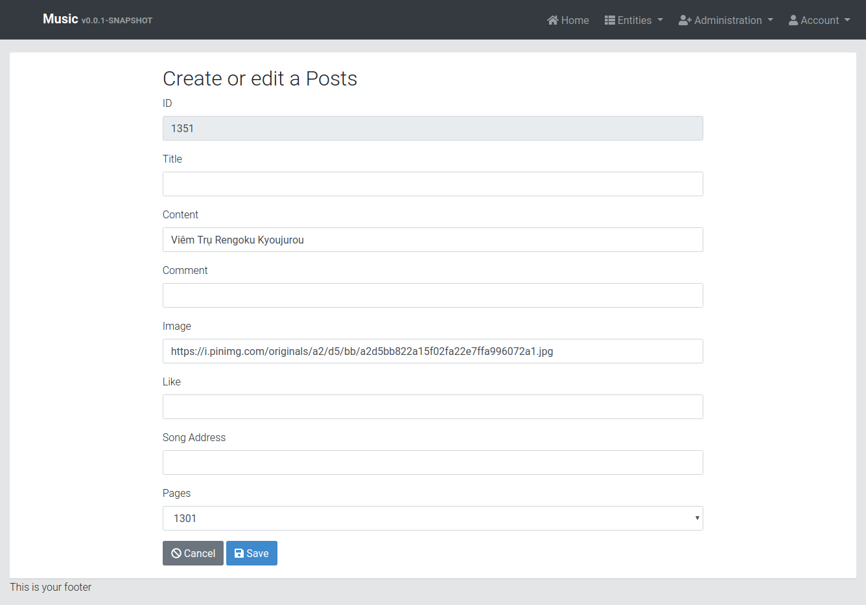

Delete Album

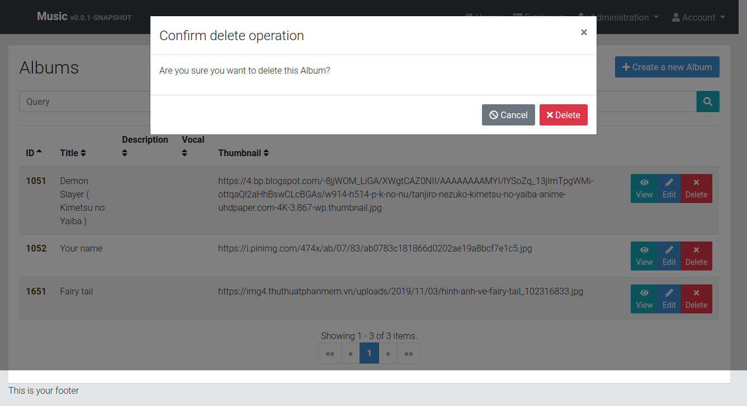

Authentication Logs

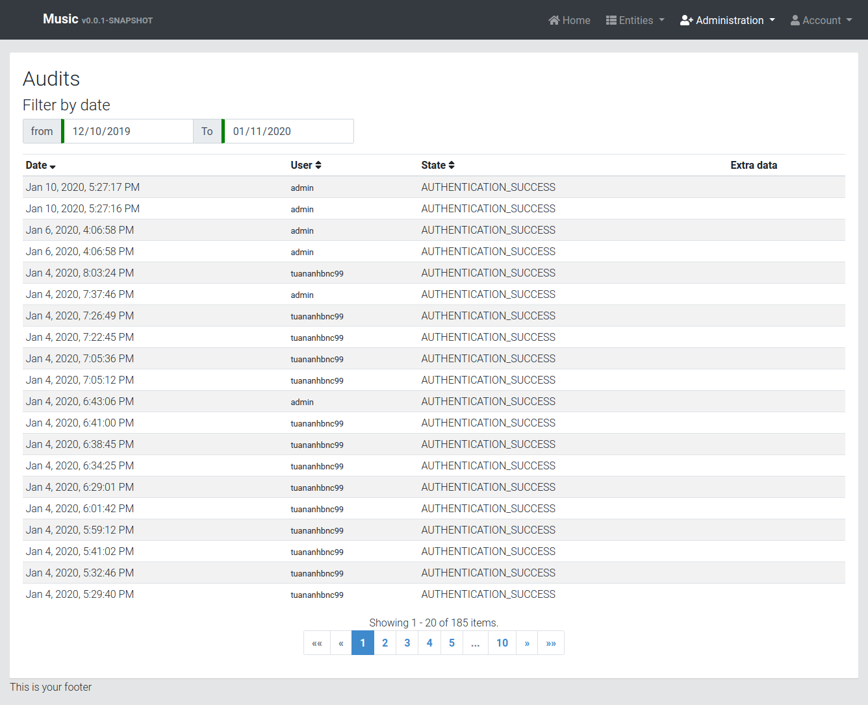

API

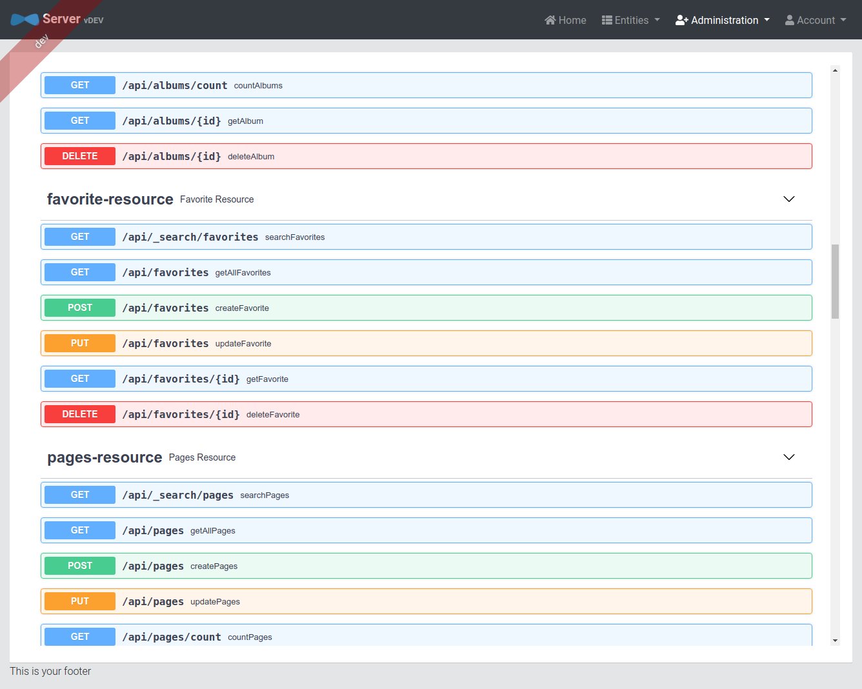

Client Login

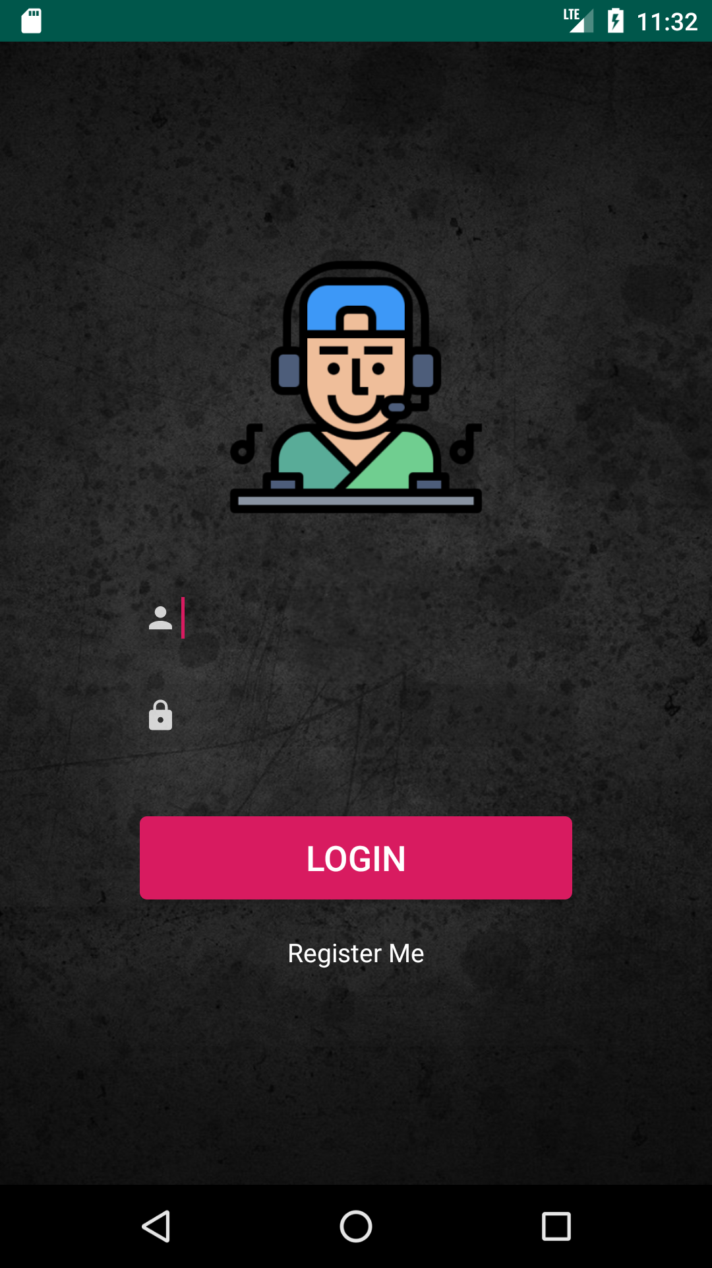

Home page

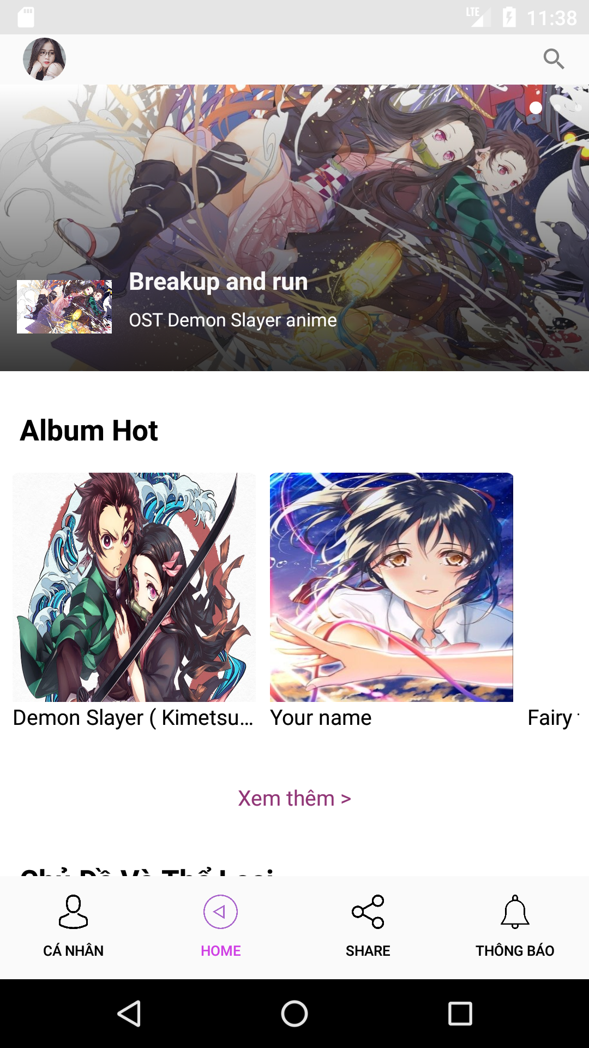

Songs

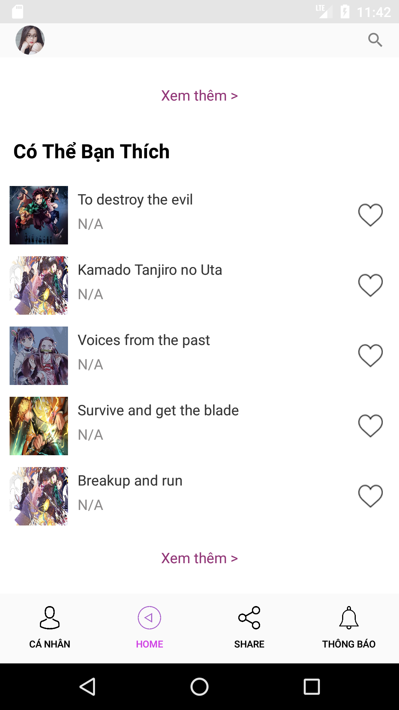

Genre

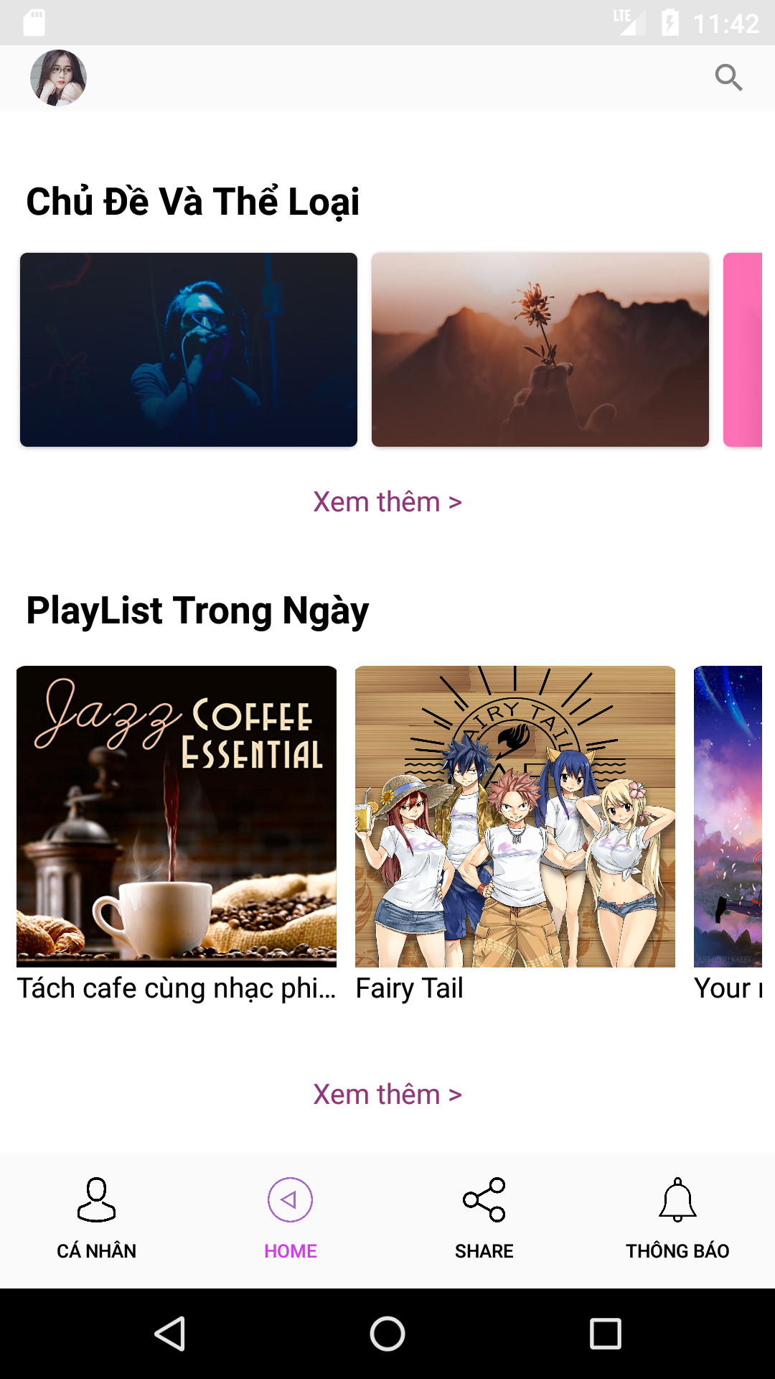

Album

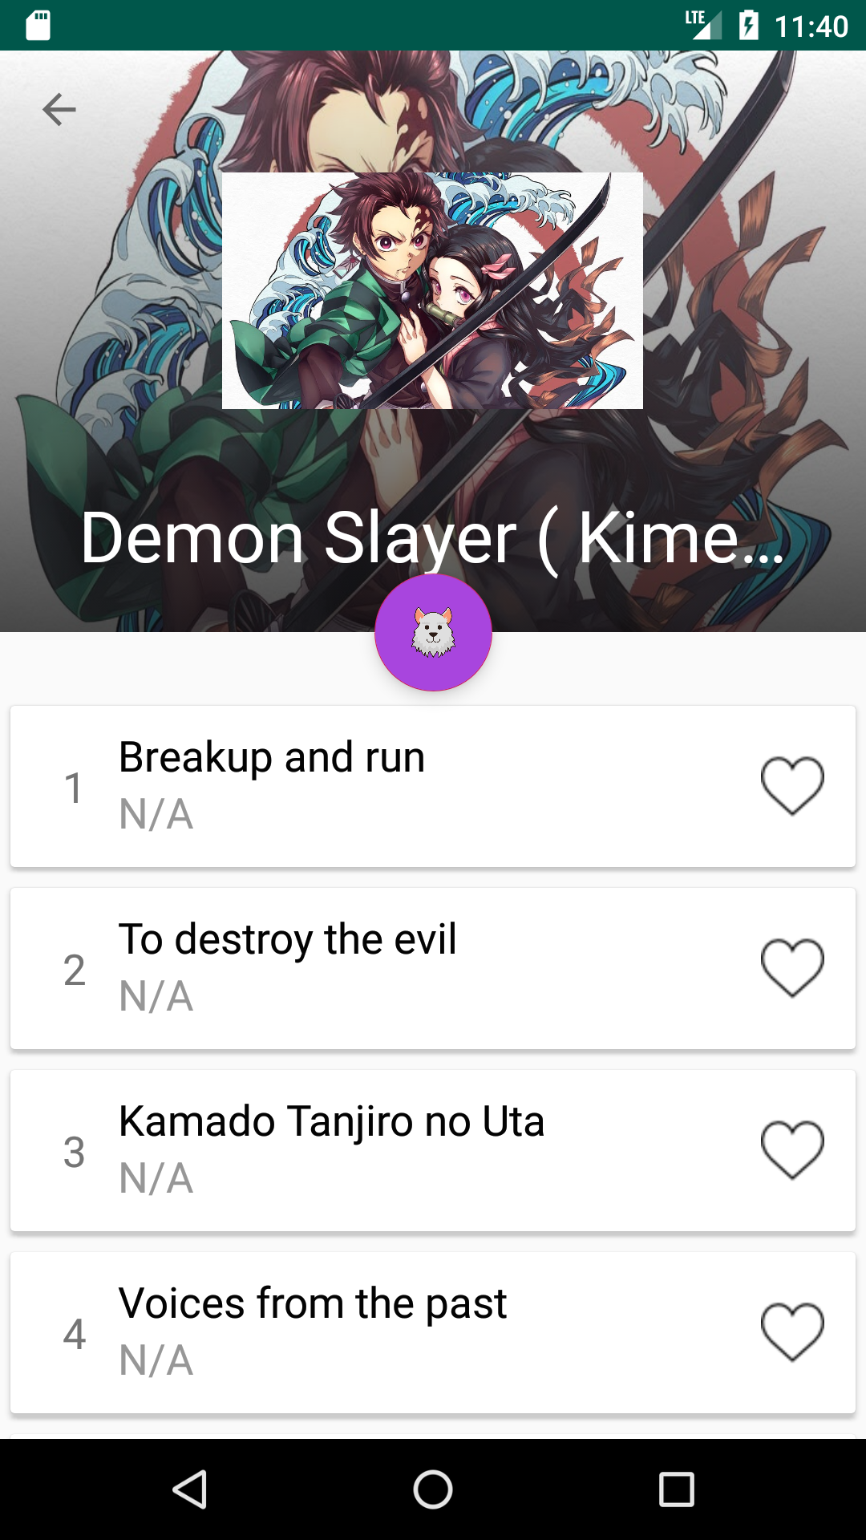

Playlist

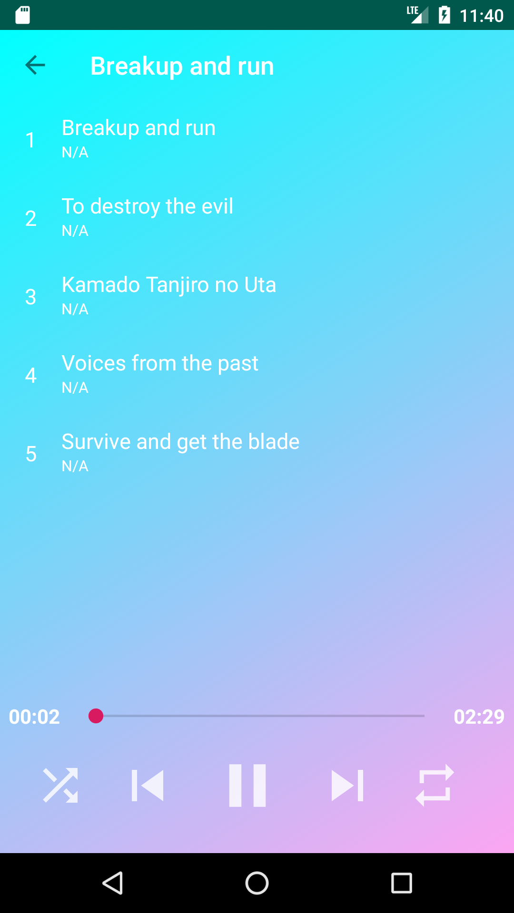

Player

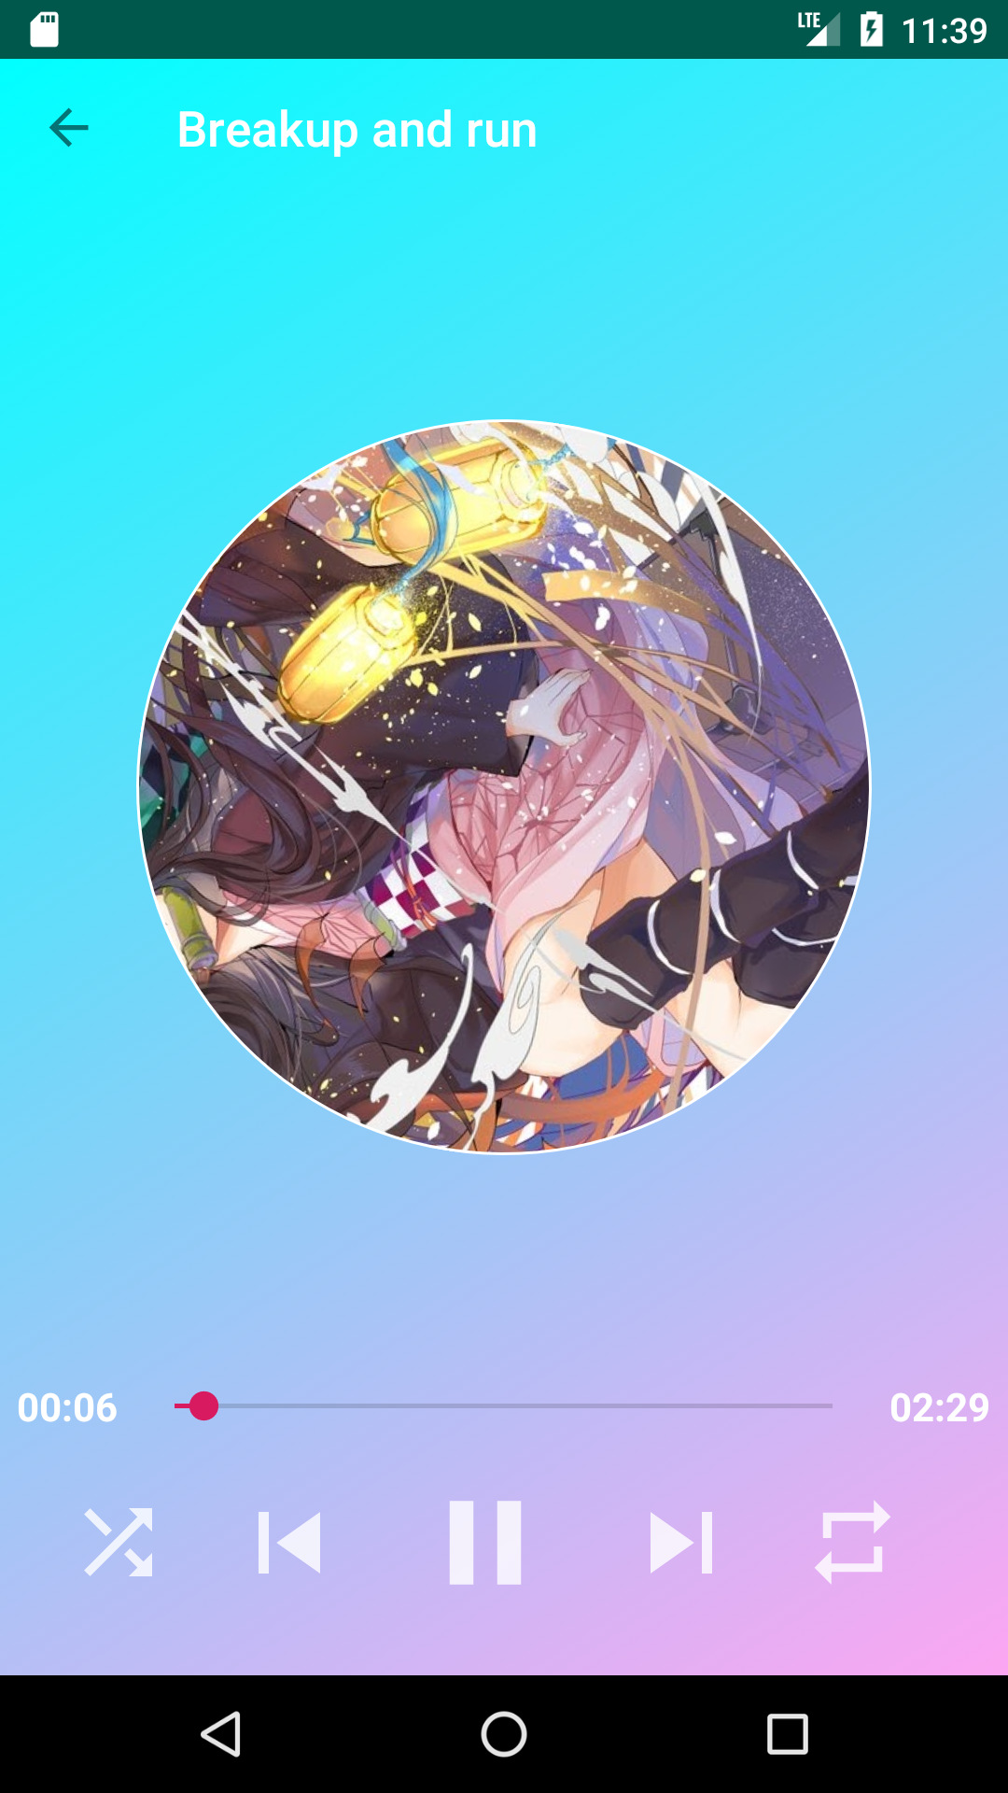

User Profile

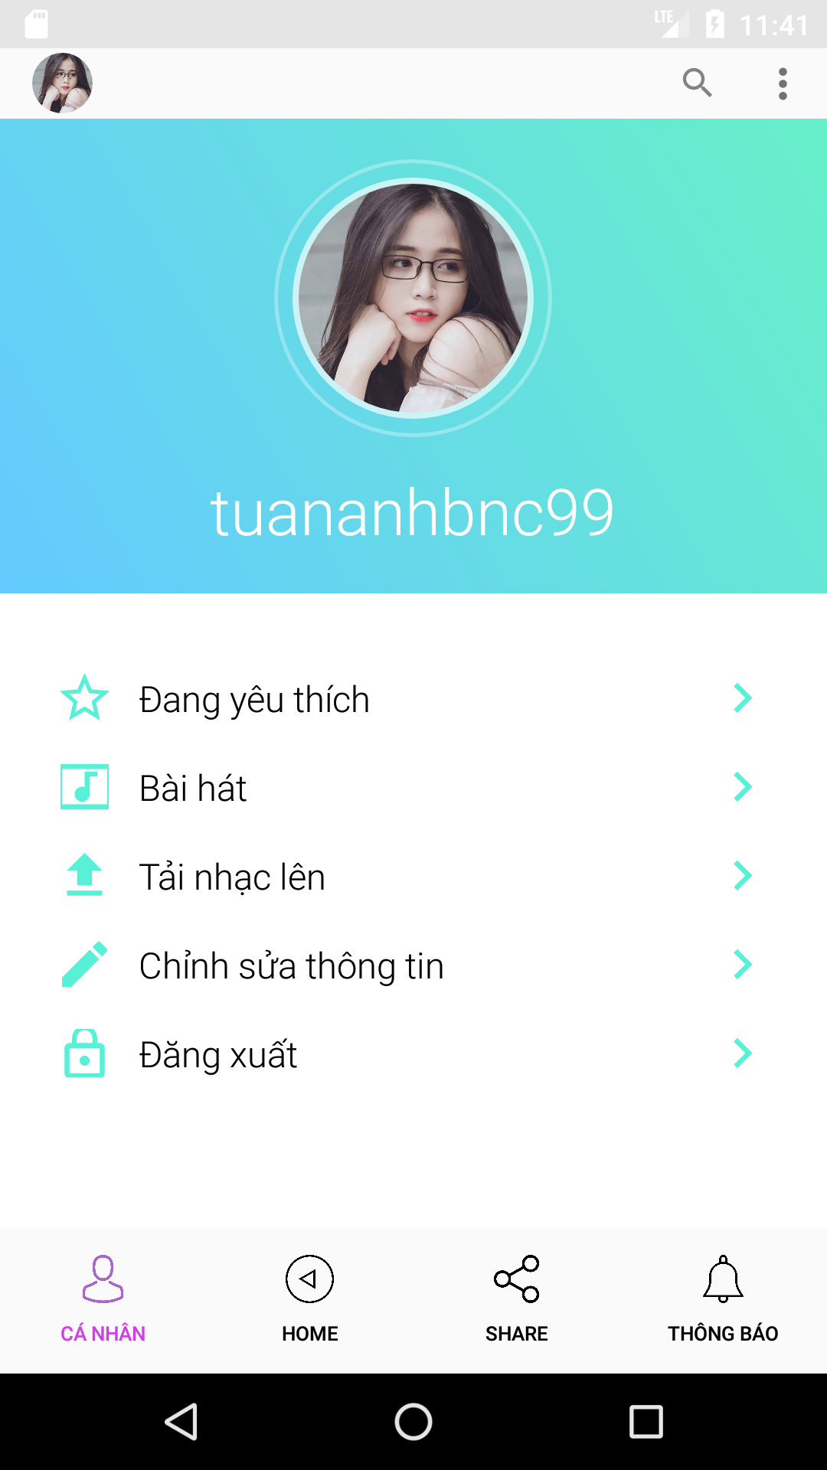

Upload Song

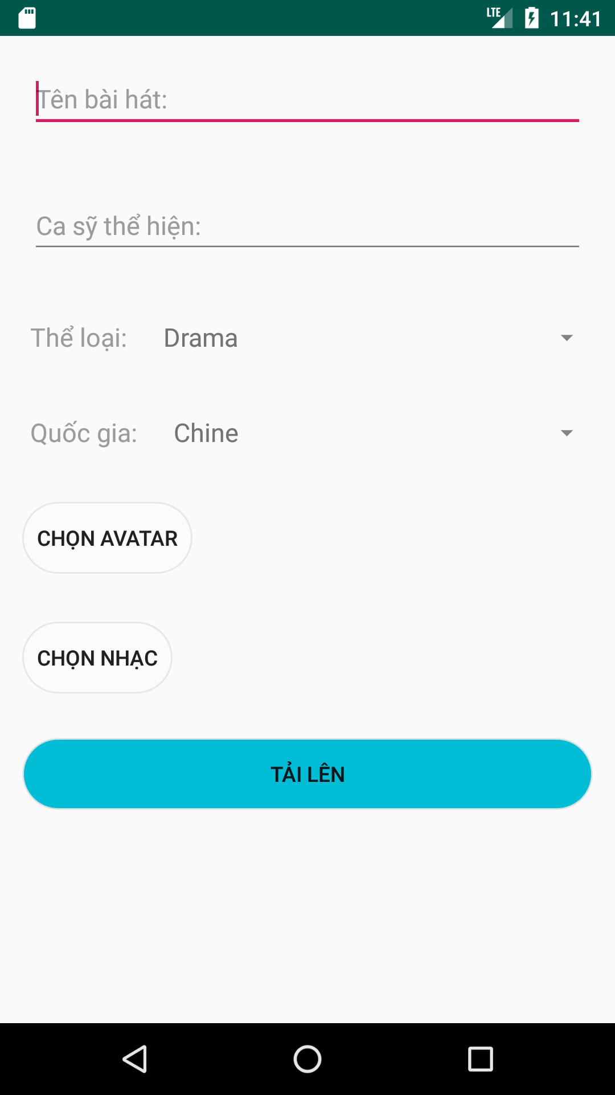

Update Profile



